Building Wealth & Your Income Opportunity

Business Owner Mindset

-
-
-
-

How much is foolish Spending Costing You?

- ___________________________________________________________

Dave Ramsey Money Management

1.
2.
3.
4.
5.
6.

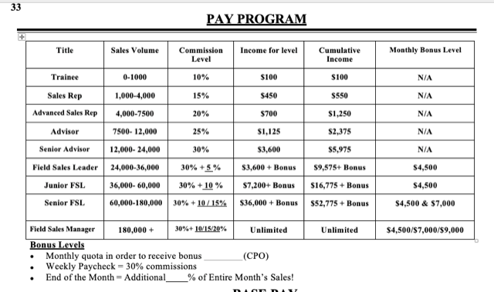

Full-Time/Part-Time at 40%

________________________________________________________________________________________________________________________________
________________________________________________________________________________________________________________________________

Why People Become a Branch

-
-
-
-
-

Employee vs Entrepreneur Wealth Building

Example: 30 yrs of 200k per year Earnings
Employee: 30x200,000 – 49% tax rate= $3,060,000
Entrepreneur with a Corporation: 30x200,000- 19% tax rate= $4,860,000

Investing the Difference using a Wealth Simple Return:
$1,800,000 becomes:

$4,288,900!!!!!!

Wealth Simple

________________________________________________________________________________________________________________________________

Building Wealth

Is so ________________, yet _____________________.

Entrepreneurship is: ________________________________________________________________________________________________________________________________

How To Make Money While you Sleep?

1.

2.

3.

